Урок аудирования в 7 классе (cпецгруппа)
Тема урока: “Complaining About a Package Holiday”.
Цель урока: учащиеся понимают содержание диалога и умеют адекватно реагировать
на задания учителя к данному диалогу.
Учебные задачи урока:
1) отработка произносительных навыков учащихся на основе скороговорок
и новых лексических единиц;
2) активизация употребления в речи учащихся лексических единиц по
теме “Holidays. Travelling”;
3) cовершенствование навыков устной речи.
Познавательные задачи: расширение лингвистического и общего кругозора учащихся;
Развивающие задачи: наблюдение, анализ, развитие умения общаться на иностранном
языке.
Воспитательные задачи: воспитание интереса к учению, привитие навыков вежливого
общения с окружающими.
Оборудование: ТСО, диск с записью диалога, карта мира, печатные листы с заданиями.
Ход урока:
I. Организационный момент (приветствие учителем детей, сообщение темы урока).
– Good morning, dear pupils! At this lesson we’ll practice listening comprehension.
The topic is “Complaining about a package holiday”. You learn how to fill in a Customer
Complaint Form in case of a spoilt holiday if a tour agency is guilty in it.
II. Фонетическая зарядка.
– First of all, let’s tune up for English. Look at the blackboard and repeat these two tongue
twisters after me. (На доске записаны две скороговорки по теме ”Travelling”:
NEVER TRY TRAVELLING BY TRAIN IN A DRY COUNTRY LIKE TRINIDAD.
HE WAS CURED DURING HIS TOUR OF EUROPE.
Учащиеся повторяют скороговорку хором, затем группами (сначала мальчики, потом
девочки) и, наконец, индивидуально.
– There are a lot of islands for holiday-makers to rest. Let’s name them.
(На доске – названия всемирно известных островов:
CANARY, MALDIVES, BERMUDA, SEICHELLES.
Далее следует отработка этих названий в речи учащихся хором и индивидуально.)
And now show them in the map of the world.

(Ученики по очереди выходят к доске, находят на карте мира обозначенные звездами
места и произносят их названия вслух на английском языке.)

III. Подготовительный этап.
– We are living in one of the most popular countries among the tourists. But the service is
not always perfect here. Please make a list of problems tourists may have on holiday, for
example, they may lose their passport or not like the food.
(Дети по очереди называют возможные проблемы отдыхающих:
lose money, may not like the hotel, lose the way, get lost, be robbed, may not like the view,
be short of money.)

IY. Основной этап.
– Before I play the disk, have a look at the “Key Language” section. These words will help
you to understand the dialogue properly. (Ученики смотрят на список слов к диалогу,
учитель контролирует понимание ими данных ЛЕ) Now you are going to listen to
a conversation in which three people are involved. You must decide where the dialogue
takes place and who the people are.
(Ученики дают ответы на поставленные учителем вопросы.)

– And the second listening. (Учитель раздает каждому ученику the Customer Complaint
Form.) You must listen again and complete the form as if you are a travel agent.
(Учащиеся слушают запись повторно и заполняют бланк жалобы клиента.)

– Now exchange your papers and check them up. I will give you correct answers. Put
the marks according to the scale:
no mistakes / one mistake – excellent;
two / three mistakes – good;
four / five mistakes – satisfactory;
more than five mistakes – poor.

– The next task. Disagree with my statements. Use the following phrases of disagreement:
I disagree. (I’m afraid) you are wrong. I don’t think so. On the contrary.
(Учащиеся по очереди реагируют на неправильные утверждения учителя и исправляют
эти высказывания.)

– It’s time now to practice this conversation. Let’s role-play the dialogue.
(Ученики читают диалог по ролям.)

Y. Подведение итогов. Домашнее задание
– Write down your home assignment:
1) Render 13 sentences in English in your exercise-books (см. Приложение).
2) Learn the tongue-twisters by heart.
3) Get ready for the word dictation (11 key words), compose sentences with them and
write them in your exercise-book.

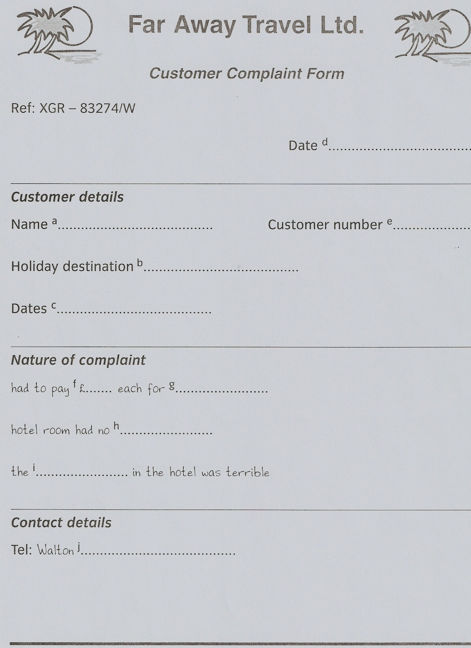 Tapescript. BUT IT SAYS HERE.
Travel agent: Can I help you?
Mrs Caldwell: Yes, you can actually. We came back from Bermuda last night. This is the brochure of
the holiday you sold us.
Travel agent: Oh yes. Did you have a nice time?
Mr Caldwell: No, we didn’t. My wife and I are both very angry.
Travel agent: Oh dear. What was the problem?
Mrs Caldwell: Well, to start with we had to pay 20 pounds extra each for airport tax. But it says here
in the brochure airport tax is included.
Travel agent: Oh yes, so it does.
Mr Caldwell: And our room didn’t have a sea view. We paid extra for a sea view but all we got was
a view of the car park at the back of the hotel.
Travel agent: Oh dear. This is very serious. I think we should fill out a complaint form. Now, what
are your names?
Mrs Caldwell: It’s Mr and Mrs Caldwell. That’s C-A-L-D-W-E-L-L.
Travel agent: OK… And the holiday was in Bermuda?
Mrs Caldwell: Yes. Two weeks, from the tenth to the twenty-fourth of February.
Travel agent: Tenth to twenty-fourth of February. And today is the twenty-fifth. OK. Do you have
your customer number?
Mr Caldwell: It’s here on the receipt. DW83247.
Mrs Caldwell: Oh yes. OK. Now, you had to pay 20 pounds each for airport tax, and the hotel room
had no sea view…
Mr Caldwell: And you can add that the food in the hotel was terrible.
Mrs Caldwell: I couldn’t eat a thing. We lived on sandwiches, didn’t we, darling?
Mr Caldwell: Yes. I lost a kilo in weight.
Travel agent: Oh… so… the food in the hotel was terrible. Oh dear.
Mrs Caldwell: Well, what are you going to do about it?
Travel agent: I’ll send this complaint to our Head Office, and I’ll phone you when I get a reply. Can I
have a telephone number?
Mrs Caldwell: It’s Walton 8932443.
Travel agent: Walton 8932443. OK. Well, I’m very sorry about this.
Mr Caldwell: It was an awful experience. We want our money back.
Travel agent: I’ll see what I can do. Our apologies once again.
Mr and Mrs Caldwell: Goodbye.
Travel agent: Another one for the bin!

ПРИЛОЖЕНИЕ

Tongue-twisters:

- Never try travelling by train in a dry country like Trinidad.

- He was cured during his tour of Europe.

Disagree with the following statements.

1. The Caldwells came from the Maldives last night.
2. They are very cheerful and merry.
3. The Caldwells didn’t have to pay airport tax.
4. Their room had a sea view.
5. Their holiday lasted ten days.
6. The Caldwells came to the travel agency on the twenty-first
of February.
7. They enjoyed the food which was delicious in the hotel.
8. Mr Caldwell gained a kilo in weight.
9. The manager sent them to the Head Office.
10. The Caldwells wanted to receive a souvenir from the travel
agency.

Rendering:

- Семейная пара пришла в турагенство.
- Они очень сердиты.
- Им не понравился их отдых на Бермудах.
- Они назвали три причины для этого.
- Во-первых, им пришлось заплатить лишних 20 фунтов каждому в аэропорту.
- Но этот налоговый сбор включен в стоимость поездки.
- Во-вторых, окна их номера в отеле не выходили на море.
- Они могли видеть только автомобильную стоянку.
- В-третьих, еда в отеле была ужасная.
10. Они жили на бутербродах.
11. Мистер Колдуэлл потерял 1 кг веса.
12. Колдуэллы сказали, что это был ужасный опыт.
13. И теперь они хотят вернуть свои деньги.
КЛЮЧИ К ЗАДАНИЯМ ПО АУДИРОВАНИЮ.

Answer Key №1.
The conversation takes place in a travel agent’s. One man is a travel agent,
the other two re a married couple who have just returned from holiday.

Answer Key №2.
a Mr & Mrs Caldwell
b Bermuda
c February 10th – 24th
d February 25th
e DW83247
f 20 pounds
g airport tax
h sea view
i food
j 893 2443

